COUNCIL ASSESSMENT REPORT

Panel Reference | PPSWES-78
DA Number | D21-211
LGA | Dubbo Regional Council
Proposed Development | Electricity Generating Works (Solar Farm)
Street Address | Lots 95, 190 & 303 DP 754308, Lots 3 & 4 DP 252285 - Wellington Road DUBBO &  Lot 10 DP 754287 - 47R Wellington Road DUBBO
Applicant/Owner | Applicant: Dubbo Solar Project Pty Ltd  Owner: B J Jackson
Date of DA lodgement | 1 April 2021
Total number of Submissions | 1
Recommendation | Approval – subject to conditions
Regional Development Criteria (Schedule 7 of the SEPP (State and Regional Development) 2011 | Private infrastructure for the purpose of electricity generating works with a  capital investment value of more than $5 million.
List of all relevant s4.15(1)(a) matters | - State Environmental Planning Policy (Infrastructure) 2007  - State Environmental Planning Policy No 33 – Hazardous and Offensive Development  - State Environmental Planning Policy No 55 – Remediation of Land  - State Environmental Planning Policy (State and Regional Development) 2011  - State Environmental Planning Policy (Primary Production and Rural Development) 2009  - Dubbo Local Environmental Plan 2011
List all documents submitted with this report for the Panel’s consideration | - Site Plan  - Location Diagram  - DC Coupled Energy Storage Container Elevations  - Central Inverter, HV Switchboard, O/H Pole Elevations  - Construction and Operation Noise Assessment Report  - Bush Fire Assessment and Emergency Management Operation Plan  - Landscape Screening Plan  - Landscape Specifications  - Written Documentation from applicant dated 19 May 2021  - Dubbo Solar Farm Flood, Drainage and Groundwater Assessment  - Gas Fire Extinguisher System  - Biodiversity Assessment  - Submission - Adjoining Owner  - Traffic Impact Assessment report  - Glint and Glare Impact Assessment  - Landscape and Visual Impact Assessment
Clause 4.6 requests | Not applicable
Report prepared by | Tracie Smart
Report date | 28 May 2021
Summary of s4.15 matters  Have all recommendations in relation to relevant s4.15 matters been summarised in the Executive Summary of the assessment report? |  | Yes
Legislative clauses requiring consent authority satisfaction  Have relevant clauses in all applicable environmental planning instruments where the consent authority must be satisfied about a particular matter been listed, and relevant recommendations summarized, in the Executive Summary of the assessment report?  e.g. Clause 7 of SEPP 55 - Remediation of Land, Clause 4.6(4) of the relevant LEP |  | Yes
Clause 4.6 Exceptions to development standards  If a written request for a contravention to a development standard (clause 4.6 of the LEP) has been received, has it been attached to the assessment report? |  | Not applicable
Special Infrastructure Contributions  Does the DA require Special Infrastructure Contributions conditions (S7.24)?  Note: Certain DAs in the Western Sydney Growth Areas Special Contributions Area may require specific Special Infrastructure Contributions (SIC) conditions |  | Not applicable
Conditions  Have draft conditions been provided to the applicant for comment?  Note: in order to reduce delays in determinations, the Panel prefer that draft conditions, notwithstanding Council’s recommendation, be provided to the applicant to enable any comments to be considered as part of the assessment report |  | Yes

EXECUTIVE SUMMARY

Description of Proposal

Council is in receipt of a Development Application for an electricity generating works (solar farm) at Lots 95, 190 & 303 DP 754308, Lots 3 & 4 DP 252285 - Wellington Road DUBBO & Lot 10 DP 754287 - 47R Wellington Road DUBBO.

The proposed development includes the installation of approximately 16,128 x 450 watt solar panels (2.1m x 1.05m x 0.4m deep) which are mounted on single axis tracking systems (resulting in an overall height of 1.4m). Additionally, and as indicated in Figures 1 and 2 the following associated infrastructure will be provided to support the solar farm operation:

- Power station (13m (l) x 2.5m (w) x 3m (h)) consisting of an inverter, transformers and switch gear;
- A high voltage switchboard (5m (w) x 5m (l) x 4m (h)) consisting of high voltage switch gear;
- Battery storage (13m (l) x 2.5m(w) x 3m (h));
- 4 x Electrical poles (12m (h) each);
- Hardstand vehicle area;
- Site fencing (1.8m (h) chain mesh);
- Site access/internal driveway construction and;
- Landscaping.

The solar farm development will have an overall footprint of approximately 17ha and is intended to have a 31 year lifespan from the beginning of construction with the project to be decommissioned and the site rehabilitated as the conclusion of its use, allowing the site to be re-utilised for its previous agricultural use.

The proposed development will have a maximum output of 5 megawatts, operate 24 hours, 7 days per week and will not be staffed other than during the construction phase and for ongoing maintenance purposes (a maximum of two (2) staff attending the site up to 3 times per month).

The proposed development is considered to be regional significant development due to its capital investment value being over $5million ($6,456,208 ex GST) and as such the application shall be referred to the Western Regional Planning Panel for determination.

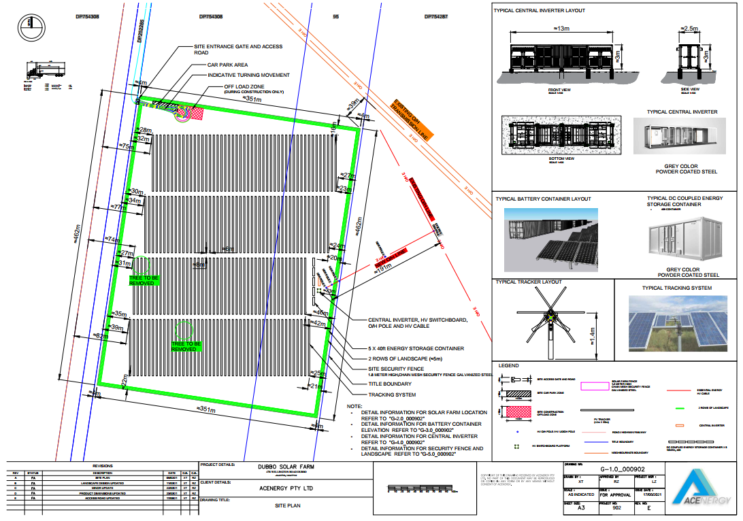
Figure 1: Submitted detail site plan

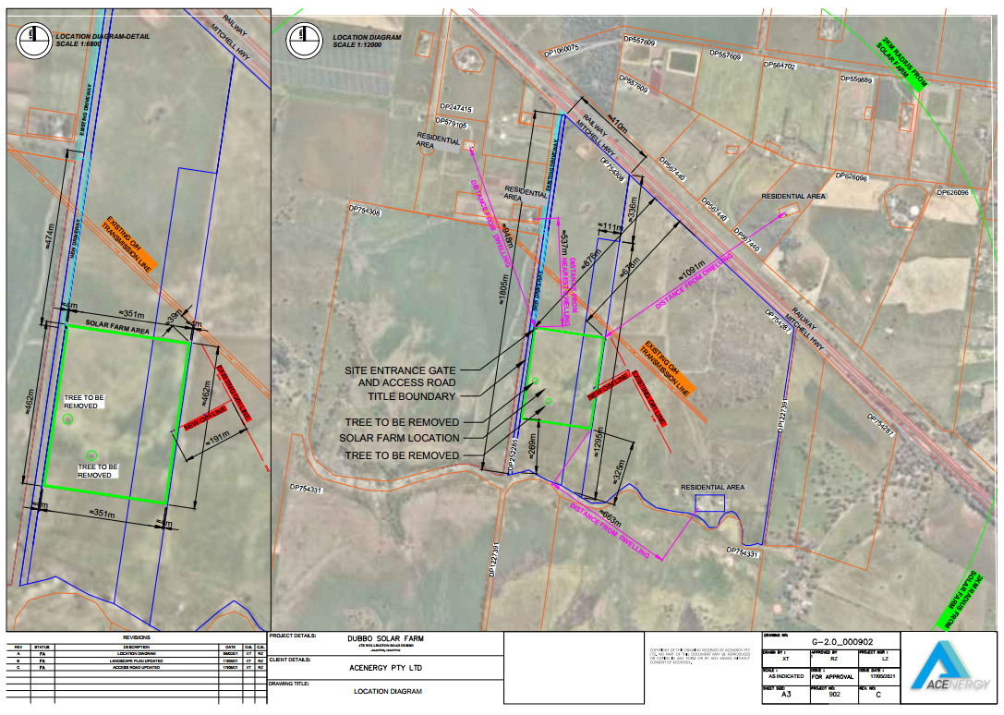
Figure 2: Submitted overall site plan

Site Description and Surrounding Land Uses

The overall site is located on the southern side of Wellington Road (Mitchell Highway) and the eastern side of Basalt Road. The site has an overall area of approximately 183ha. An existing dwelling is located on Lot 10 DP754287. For a locality map of the site see Figure 3.

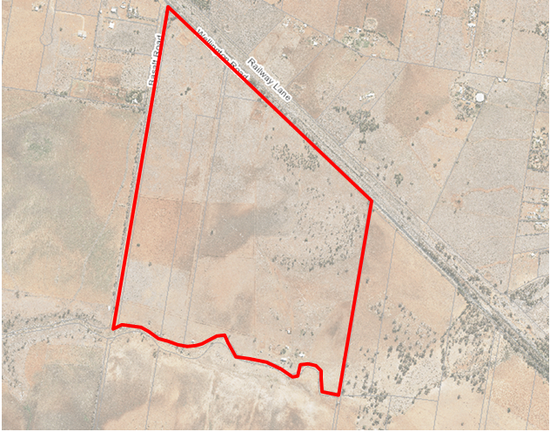
Figure 3: Site location Lots 95, 190 & 303 DP 754308, Lots 3 & 4 DP 252285 - Wellington Road DUBBO & Lot 10 DP 754287 - 47R Wellington Road DUBBO.

Slope
The site slopes gently from 342mAHD in the north east to 312.5mAHD in the south west.

Vegetation
The site is generally void of native vegetation due to the existing agricultural use of the site.

Access
Access to the site is obtained via Mitchell Highway/Wellington Road a sealed classified road and then Basalt Road an unsealed public road with grassed table drains.

Drainage
Drainage would be managed onsite.

Services
The site would be connected to electricity infrastructure.

Adjoining uses
North RU2 zoned land used for rural and rural residential purposes.
South RU1 zoned land used for rural and rural residential purposes.
East RU1 zoned land used for rural purposes.
West RU2 zoned land used for rural and rural residential purposes and IN3 zoned land beyond that is partly vacant and partly occupied by an extractive industry (Holcim)

Site Inspection
An inspection of the site was conducted on 5 May 2021, a number of photographs are included on file.

Site History

The site has been the subject of a number of Development Applications over the years however all relate to the exiting dwelling on the site and are not relevant to the subject application. There are no issues from previous development approvals, which require further consideration.

RECOMMENDATION
The proposed development is considered to be generally compatible with its surrounds and provides for a diversification of land uses on the property without adversely impacting the existing agricultural use of the land.
As a result of this assessment, the proposed development is recommended for conditional consent.
Appendix 1 to this report contains the proposed conditions of consent.
Recommendation:
a) That having regard to the assessment of the application, DA2021-211 (WRPP Ref PPSWES-78) be granted conditional consent in the terms set out in Appendix 1 to this report.

PLANNING ASSESSMENT Section 4.15(1)

As required by the Environmental Planning & Assessment Act, 1979, Section 4.15(1), the following relevant matters are addressed below:

- environmental planning instruments (State Environmental Planning Policies (SEPPs) and Local Environmental Plans (LEPs);
- draft environmental planning instruments;
- development control plans;
- planning agreements;
- regulations;
- environmental (natural and built), social and economic impacts;
- suitability of the site;
- submissions; and
- public interest.

(a)(i) Environmental Planning instruments

SEPP 33 Hazardous and Offensive Development

The proposed development includes a DC Coupled Energy Storage Container in which energy generated by the PV system to be stored as required and utilised during times of high demand. They can also perform grid management functions such as frequency and voltage control.

The proposed development is not considered to pose a significant risk to locality in relation to human health, life or property, or the biophysical environment and is therefore not defined as a potentially hazardous industry.

The proposal will not emit a polluting discharge which would have a significant adverse impact in the locality or on the existing or likely future development on other land and is therefore not defined as a potentially offensive industry.
As such, no further assessment is required.

SEPP 55 – Remediation of Land

The subject land is not listed on Council register of potentially contaminated land. Council’s Environment and Health Specialist in the memo dated 21 April 2021 states:

Previously the land was used for grazing and other agricultural purposes. No contamination risk is associated with this development and, provided waste is disposed of mindfully, no contamination risk is associated with this development. No further studies required.

A condition of consent in relation to waste classification and disposal shall be imposed.

SEPP (Infrastructure) 2007

Division 4 Electricity generating works or solar energy systems

The subject land is zoned RU2 Rural Landscape which is identified as a prescribed rural zone under Clause 33. The proposed development is considered development permitted with consent in accordance with Clause 34(1)(b) as follows:

34 Development permitted with consent
(1) Development for the purpose of electricity generating works may be carried out by any person with consent on the following land—
(a) …
(b) in any other case—any land in a prescribed rural, industrial or special use zone.

It is noteworthy to confirm that the proposed development cannot be considered exempt development primarily due to its size (exceeds 150m²) and electricity generating capacity (exceeds 10kW) – clause 39(3)(e).

Clause 45

The application was referred to Essential Energy in accordance with Clause 45 for which they responded in correspondence dated 29 April 2021, raising no objection to the proposed development. The requirements specified by Essential Energy will be included on the development consent as notations, as Council is unable to enforce such requirements.

Clause 101 Development with frontage to classified road

The site of the proposed development has a frontage to a classified road and is provided with an access off Basalt Road which intersects a classified road (Mitchell Highway/Wellington Road). As such, Clause 101 of the SEPP (Infrastructure) is considered.

Clause 101(2) states:

(2) The consent authority must not grant consent to development on land that has a frontage to a classified road unless it is satisfied that—
(a) where practicable and safe, vehicular access to the land is provided by a road other than the classified road, and
(b) the safety, efficiency and ongoing operation of the classified road will not be adversely affected by the development as a result of—
(i) the design of the vehicular access to the land, or
(ii) the emission of smoke or dust from the development, or
(iii) the nature, volume or frequency of vehicles using the classified road to gain access to the land, and
(c) the development is of a type that is not sensitive to traffic noise or vehicle emissions, or is appropriately located and designed, or includes measures, to ameliorate potential traffic noise or vehicle emissions within the site of the development arising from the adjacent classified road.

Access to the proposed development is not directly from the classified road, rather from Basalt Road which intersects the highway. Basalt Road is a sealed road with grassed table drains and services the existing rural and rural/residential development in the vicinity.
Due to the nature and scale of the development it is considered unlikely that adverse impacts on the safety, efficiency or ongoing operation to the classified road will result. The site is to be accessed by a design vehicle no larger than 19m, the development will not generate smoke or significant dust volumes, and significant traffic generation is unlikely. The proposed development is not sensitive to traffic noise or vehicle emissions.

Further, the development application was accompanied by a ‘Glint and Glare Impact Assessment Report, dated March 2021’ which concluded:

• No glare potential was found to affect dwellings and transport routes within 2km of the
Project when the solar farm is operating normally using a horizontal single axis tracking
system;
• No glare potential was identified for dwellings and transport routes when the tracking
system resting angle was set at 45 degrees and 5 degrees – simulating a backtracking
operation;
• No glare potential was found to affect flight paths at the approach to runways at Dubbo
City Regional Airport, 7.5km from the Project site;

As such, the consent authority is satisfied that the proposed development will not adversely impact the safety, efficiency and ongoing operation of the classified road nor will it be adversely impacted by the use of the inherit use of classified road. No further investigations are required.

SEPP (State and Regional Development) 2011

Schedule 7 of the SEPP specifies development that is declared to be regionally significant development. Pursuant to Section 5 of the Schedule 7, the proposed development is considered to be regionally significant development as it is private electricity generating works infrastructure with a capital investment value of more than $5 million ($6,456,208 ex GST). Consequently, the application will be referred to the Western Regional Planning Panel for determination accordingly.

SEPP (Primary Production and Rural Development) 2019

The aims of this Policy are as follows—
(a) To facilitate the orderly economic use and development of lands for primary production,
(b) To reduce land use conflict and sterilisation of rural land by balancing primary production, residential development and the protection of native vegetation, biodiversity and water resources,
(c) To identify State significant agricultural land for the purpose of ensuring the ongoing viability of agriculture on that land, having regard to social, economic and environmental considerations,
(d) To simplify the regulatory process for smaller-scale low risk artificial waterbodies, and routine maintenance of artificial water supply or drainage, in irrigation areas and districts, and for routine and emergency work in irrigation areas and districts,
(e) To encourage sustainable agriculture, including sustainable aquaculture,
(f) To require consideration of the effects of all proposed development in the State on oyster aquaculture,
(g) To identify aquaculture that is to be treated as designated development using a well-defined and concise development assessment regime based on environment risks associated with site and operational factors.
The proposed development is considered to be compatible with adjacent land uses. It is expected that the proposal would not cause land use conflict in the area.

Note: While a number of other SEPPs apply to the land, none are specifically applicable to this development.

Dubbo Local Environmental Plan 2011

The following clauses of Dubbo Local Environmental Plan (LEP) 2011 have been assessed as being relevant and matters for consideration in assessment of the Development Application.

 | Complies (Yes/No)
Part 1 Preliminary
Clause 1.2 Aims of the Plan
The proposed development is consistent with the relevant aims of Plan
Clause 1.4 Definitions
The proposed development is defined as:  electricity generating works means a building or place used for the purpose of—  (a) making or generating electricity, or  (b) electricity storage. | Consistent
Clause 2.2 Zoning of land to which Plan applies
The subject site is zoned RU2 Rural Landscape | Consistent
Clause 2.3 Zone objectives and Land Use Table
The proposed development is permitted with consent in the RU2 zone pursuant to Clauses 34 of the SEPP (Infrastructure) 2007.  Further, the proposed development is consistent with the following relevant objective of the zone:  • To provide for a range of compatible land uses, including extensive agriculture.  In this regard, the proposed development is considered compatible with the agricultural use of the land. The subject land will continue to support agricultural practices whilst the electricity generating works (solar farm) is constructed and in operation. Once the electricity generating works (solar farm) is decommissioned the site will be rehabilitated to re-establish the agricultural use of the site in its entirety. | Yes
Clause 5.10 Heritage Conservation
No heritage items are located on the site. No known Aboriginal sites are located on the site however, there are a number of known Aboriginal sites to the east and west particularly in proximity to the Eulomogo Creek.  An AHIMS search was undertaken which found no nearby artefacts. Council’s Environmental Systems Planner in the memo dated 20 April 2021 states:  The cropping history of the site is sufficient evidence that the site is classified as “disturbed” under the “Due Diligence Code of Practise for the Protection of Aboriginal Objects in NSW.”  As a result of this, and the AHIMS search which has been carried finding no nearby artefacts it is confidently believed that the project will have no impact on Aboriginal Objects.  As such, no further investigations are required. | Yes
Clause 5.14 Siding Spring Observatory – maintaining dark sky
The proposed development is considered unlikely to adversely affect observing conditions at the Siding Spring Observatory having regard to the following matters:  (a) the amount and type of light to be emitted as a result of the development and the measures to be taken to minimise light pollution,  (b) the impact of those light emissions cumulatively with other light emissions and whether the light emissions are likely to cause a critical level to be reached,  (c) whether outside light fittings associated with the development are shielded light fittings,  (d) the measures to be taken to minimise dust associated with the development,  (e) the Dark Sky Planning Guideline published in the Gazette by the Planning Secretary. | Yes
Clause 7.2 Natural resource - biodiversity
The subject site is included on the Natural Resource Biodiversity Map with high value biodiversity. However, the site for the proposed development is located at least 250m from the closest identified area of biodiversity. As such, the proposed development is unlikely to result in an adverse impact. In this regard, no further action is required.  The proposed development may impact native grasses. Such impact will be considered under Biodiversity Conservation Act 2016 And Fisheries Management Act 1994 below in the report. | Yes
Clause 7.3 Earthworks
The proposed development will require earthworks to be undertaken upon the site. Erosion and sediment control measures are required before any earthworks commence in which a condition to this effect will placed on the consent. | Yes. Condition of consent recommended.
Clause 7.4 Natural resource – riparian land and waterways
Eulomogo Creek is located along the southern boundary of the overall subject land. Due to the distance between the proposed site and Eulomogo Creek it is considered unlikely any advsere impacts will result. Council’s Environmental Systems Planner in the memo 20 April 2021 states:  This project will not impact on any waterways, there is negligible excavation involved in construction and vegetation beneath the development will remain allowing rainfall infiltration to remain effective across the site.  The site compound will require a small amount of clearing, as will the surrounding asset protection zone (site perimeter road). Standard erosion and sediment control conditions will be sufficient to manage these issues on this site.  Project installation and decommissioning will have a similar localised impact to cropping of the site, again standard erosion and sedimentation controls will be sufficient in this instance. | Yes. Condition of consent recommended
Clause 7.5 Groundwater vulnerability
Clause 7.5 of Dubbo Local Environmental Plan 2011 applies as the land is included on the Natural Resource – Groundwater Vulnerability Map with both moderately high and high groundwater vulnerability. The proposed development is not likely to cause groundwater contamination nor will it likely have an effect on any groundwater dependent ecosystems. It is also considered not likely to have a cumulative impact on groundwater. Council’s Environmental Health Specialist in the email dated 5 May 2021 provided the following comment:  Given that the transformer is fully self-bunded, contamination of ground and surface water is unlikely. A spill management kit within the site should suffice to ensure that any emergency issues are dealt with in a timely and appropriate manner.  A condition to that effect will be imposed. | Yes. Condition of consent recommended.
Clause 7.7 Airspace operations
The subject site is located within the Obstacle Limitation Surface Map at height 430mAHD. The site for the proposed development has a surface level of 330mAHD and with the development having a height of 12m that equates to an overall height of 342mAHD, 88m below the surface map. | Yes
(a)(ii) Draft Environmental Planning instruments

No draft environmental planning instruments apply to the land to which the Development Application relates.

(a)(iii) Development control plans

Dubbo Development Control Plan 2013

An assessment is made of the relevant chapters and sections of this DCP. Those chapters or sections not discussed here were considered not specifically applicable to this application or are discussed elsewhere in this report.

Chapter 2.4 Rural Development and Subdivision

 | Complies?
Elements 1 Site Integration
The proposed development is to be setback 43m from the western boundary, 269m from the southern boundary, 1km from the eastern most boundary and 900m from the northern boundary.  The site of the development is located approximately 537m from a dwelling to the north west and approximately 663m from a dwelling to the south east (such dwelling is located on the land subject to this application).  The proposed development will be provide with a 5m vegetation buffer within the internal boundary fence to address potential visual amenity impacts in relation to the dwelling in proximity to the site.  The proposed development is located in proximity to electrical infrastructure as required.  Due to the nature of the development, no further action is required. | Yes
Element 2 Services
The proposed development requires connection into the electrical network. The HV Switchboard would connect via underground cables to one of the three (3) new power poles constructed within the compound which would then transfer the electrical load via overhead power lines to the nearby Essential Energy substation.  Water, sewer and stormwater infrastructure is not available nor required for the proposed development to be undertaken. No further action is required. | Yes
Element 3 Access
Access to the site is to be via the Mitchell Highway (Wellington Road) and then Basalt Road. An internal driveway is to be provided to permit vehicular access to the site from Basalt Road. It is noted that an internal access road has been constructed during the assessment period of the application. This internal road was constructed by the land owner to provide an alternate access to his dwelling and cattle yards and was not related to the proposed development. Regardless, conditions of consent will require the access to be constructed/upgraded in accordance with Council’s standards and specifications. | Yes
Element 4 Design for Access and Mobility
This element refers to designing residential development to provide access and mobility for people with a disability and to facilitate and encourage the design and construction of adaptable housing. The proposed development does not include such land uses. | N/A
Element 5 Flooding
Council’s flood mapping does not extend to the subject land and as such, although the site adjoins the Eulomogo Creek, the site is not mapped as flood prone. Due to the lack of flood mapping data, the development application was accompanied by a ‘Flood, Drainage and Groundwater Assessment, dated 15 March 2021’ which used modelling to assess the level of flood risk for the development under existing and estimate climate change conditions. The existing scenario was assessed for the 1% Annual Exceedance Probability (AEP) flood event.  The assessment concluded the site is not impacted by flooding from the Eulomogo Creek however, is impacted by minor and shallow overland flow paths which enter the site from the north east. For the 1% AEP the flood depth at the site is generally less than 0.1m however in small patches depths reach 0.15m.  The report makes the following recommendations:  - for solar panels proposed in the inundated area it is recommended that these are located above the 1% AEP flood level  - For any critical infrastructure it is recommended that it be sited 300m above the 1% AEP level.  These recommendations will form conditions of consent. | Yes
Element 6 Waste Management
A Waste Management Plan was submitted with the development application. Standard conditions of consent are recommended.  The application details that no later than 12 months prior to the proposed cessation of operation a decommissioning plan be prepared and provided to Council for review and approval. The objective of the plan would be to restore the land to is pre-existing state suitable for agricultural use. In would include, but not limited to, the following details:  - Expected timeline for rehabilitation completion;  - Decommission of all solar panels, above and below ground infrastructure, inverter stations, fencing and any other structures or infrastructure relating to the approved development; and  - Programme of site restoration to return the land back to a suitable state for agricultural purposes.  A condition requiring this plan be provided at least 12 months prior to the cessation of the development is to be imposed. | Yes. Conditions of consent recommended.
Element 7 Rural Workers Dwellings
The proposed development does not include such land uses. | N/A
Restaurants, Function Centres and Cellar Door Premises
The proposed development does not include such land uses. | N/A
Backpackers Accommodation, Farm-Stay Accommodation and Eco-Tourist Facilities
The proposed development does not include such land uses. | N/A
Signage
The proposed development does not include such development. | N/A
Physical Infrastructure and Lot Layout
The proposed development does not include any form of subdivision or boundary adjustment and as such, this element does not apply. | Yes

Chapter 3.5 Parking

The DCP does not provide a parking rate for this type or similar development. The submitted plans indicate the site is provided with a parking, manoeuvring area and offload zone (during construction only) immediately adjacent the proposed entrance gate and access road. The parking area measures approximately 40m wide x 10m deep.

Once constructed, the site will be accessed by up to two (2) vehicles up to three (3) times per month. The submitted Traffic Impact Assessment Report provided details of the expected traffic volumes to the site and the provision of parking to be provided has been identified as adequate. It is considered that suitable parking is provided to service the type and volume of vehicles expected to access the site. No further assessment required.

(a)(iii) planning agreements

Council Policy, Planning Agreement Policy for Solar and Wind Energy Farms, dated 28 April 2021 (TRIM Ref: ED21/75688) applies to the land. Such policy applies to all State and Regionally significant solar or wind energy farms with a Capital Investment Value in excess of $5 million. A notation will be included on the determination to notify the applicant of the Planning Agreement, and that they should approach Council regarding entering into an Agreement as deemed necessary.

(a)(iv) the regulations

No such regulations to which this clause refers are applicable to the proposed development.

- environmental (natural and built), social and economic impacts
As stated above, there will be minimal removal of any vegetation and as such negligible impact on the natural or built environment. There are only beneficial social and economic impacts resulting from the proposed development.

(c) suitability of the site

Context, setting and public domain

  - Will the development have an adverse effect on the landscape/scenic quality, views/vistas, access to sunlight in the locality or on adjacent properties?

The proposed development will not have any adverse effect on the landscape/scenic quality, views/vista, and access to sunlight on adjacent properties or in the locality.

  - Is the external appearance of the development appropriate having regard to character, location, siting, bulk, scale, shape, size, height, density, design and/or external appearance of development in the locality?

It is considered the external appearance of the proposed development is deemed appropriate in the context of the locality.

  - Is the size and shape of the land to which the Development Application relates suitable for the siting of any proposed building or works?

It is considered the size and shape of the land is suitable for the proposed development.

  - Will the development proposal have an adverse impact on the existing or likely future amenity of the locality?

It is considered the proposed development will not have any detrimental impact on the existing or likely future amenity of the locality.

Environmental considerations

  - Is the development likely to adversely impact/harm the environment in terms of air quality, water resources and water cycle, acidity, salinity soils management or microclimatic conditions?

It is considered that the development will not have an adverse impact on the local environment. There are no activities proposed which may cause adverse air, soil or water pollution. Appropriate conditions on the consent will ensure possible environmental impacts are minimised.

  - Is the development likely to cause noise pollution?

Noise will be generated through construction through the use of power tools, machinery and the like. An appropriate condition will be included on the consent restricting work hours to minimise impacts to neighbouring property.

Upon occupation the development is not likely to generate noise above that of neighbouring properties. No special conditions in relation to noise generation will therefore be included on the consent.

Access, transport and traffic

  - Has the surrounding road system in the locality the capacity to accommodate the traffic generated by the proposed development?

The surrounding road network is considered to have sufficient capacity to cater for additional traffic movements generated by this development. A condition of consent will require the developer to repair any damage to the immediate road network should it occur.

(d) submissions

In accordance with Chapter 2.2 of Council’s Community Participation Plan, electricity generating works require advertisement in the local print media and written notification to landowners within the general locality.

The Development Application was placed on notification ending 28 April 2021, during which time adjoining property owners were notified in writing of the proposed development and the development application was advertised in the Daily Liberal (14 April 2021).

Council received one (1) submission during the notification period. This submission listed a number of concerns however the majority of the matters related to the operation of solar farms in the wider region rather than this particular proposed development. The concerns raised relevant to this development are discussed as follows:

Submission concerns | Council comment
Removal of five (5) trees | The proposed development includes the removal of two (2) mature woodland paddock trees. As stated below, Council raises no concerns with this proposal due to the small scale nature of removal and the fact that the trees do not hold significant biodiversity value.
Contamination of groundwater & Eulomogo Creek | Conditions of consent will require areas of concerns to be bunded and erosion and sediment control to be installed and maintained. It is considered unlikely that the proposed development would result in the contamination of groundwater or Eulomogo Creek.
Vegetation buffer ongoing maintenance | A 5m wide vegetation buffer provided to the inside of the boundary fence is proposed. Such vegetation buffer will include two (2) rows of plantings, row one being offset approximately 3.5m from the site fence and row two being offset approximately 1.5m from the site fence. The buffer will have an expected mature height of approximately 5m including shrubs with a mature height of approximately 3-4m and understorey planting with a mature height of approximately 1.5m.  Council’s Environment Systems Planner has confirmed that the identified plant species are adaptable to the climate and will generally reach mature heights within 5 years.  The submitted ‘Landscape Specification Notes details that the contractor shall ensure the landscaping is provided with suitable volumes of water to maintain optimum growth and health. The applicant has confirmed the landscaping area will be suitably prepared to optimise plant life and growth. The plants will be watered on a fortnightly basis utilising a water pod and spray gun (transported by truck or ute to the site each visit). This watering schedule will be sustained for the first three months following planting. Following this time the plants will likely be maintained by rain events however as the site would be monitored for maintenance purposes (2-3 times per month) the landscape buffer is to be watered as per the initial watering schedule during times of low rain fall. The watering schedule is to be documented and updated at each site visit. Plants which have failed to grow or have been damaged would be noted on each watering visit and replaced as necessary on the following watering visit (typically within the following fortnight).  A 1.8m high security fence is to be provided to the compound with the landscaping provided to the inside of the fence. Due to the nature, scale and topography of the site no concerns are raised in relation to the visual impact of the fence from neighbouring dwellings or the classified road.  A condition of consent will require such landscaping and associated infrastructure to be maintained in perpetuity of the solar farm operation.

The submission also requests that if the development were to be approved, that a written agreement between the adjoining land owner and the developer be undertaken in which the developer would provide:

‘… a new fence halfway of 1.4klms, costs and erection by ACENERGY Pty. Creek boundary is 1.4klms so substantial buffer needs to be built to protect erosion and unwanted chemicals from all the cement and other materials that will be used in construction. Tress be planted for pleasant effect not glare.’

Although the location of the requested fence is not detailed to provide certainty, Council does not consider this request to be warranted. The developer will be required to install sediment and erosion control measures to Council’s standard to prevent any potential adverse impacts on Eulomogo Creek and the proposed vegetation buffer is considered suitable to address visual amenity issues.

As such, no further action is required.

(e) public interest

There are no matters other than those discussed in the assessment of the Development Application above that would be considered contrary to the public interest.
BIODIVERSITY CONSERVATION ACT 2016 and FISHERIES MANAGEMENT ACT 1994

The proposed development will require two (2) mature woodland paddock trees to be removed and native grasslands to be disturbed. The application was accompanied by a Biodiversity Assessment undertaken by Premise, Report No. 221249/BAR, Rev: 001B, dated 15 March 2021. Council’s Environmental Systems Planner in the memo 20 April 2021 has provided the following comments:

The site has been partially cropped as recently as 2020, and was cropped in its entirety as recently as 2014. As a result it is not believed that the site would be classified as “native Grassland”. A biodiversity impact assessment was carried out by the proponents due to the removal of two (2) mature woodland paddock trees which will be lost as a result of the project, and the small area of native vegetation associated with these trees which will also be cleared, 0.22ha.

The biodiversity impact assessment correctly concludes that the proposal does not meet any of the threshold requirements for entry into the Biodiversity Offset Scheme (BOS) and is unlikely to have a significant impact on any threatened species. The assessment further postulates that the transformation from regular cropping to permanent solar installation may well encourage re-establishment of the previous native grassland vegetation with attendant environmental benefits.

No further action is required.

PLANNING FOR BUSHFIRE PROTECTION 2019

In accordance with 8.3.5 of the Planning for Bushfire Protection 2019 document, wind and solar farms should be provided with a minimum 10 metre Asset Protection Zone (APZ) for the structures and associated building/infrastructure, and a Bush Fire Emergency Management and Operations Plan to be developed.

The proposed development intends to comply with such requirements as detailed in the submitted documentation and plans including the submitted Bushfire Assessment and Emergency Management and Operations Plan.

Such document details measures to be undertaken to minimise the risk of a bushfire threat and actions to take when the site is impacted by a bushfire event. Compliance with the submitted documents and plans will form conditions of consent.

Additionally, the applicant has addressed the battery storage fire risk in correspondence dated 19 May 2021 as follows:

Although the particular brand of the BESS equipment has not yet been selected, any BESS proposed for the project will comply with fire detection and suppression aspects noted below.
An IEC62619 test report accompanies this correspondence and the manufacturer guidelines and standard requirements to transport, install and store the batteries used in the DC coupled battery system will be strictly adhered to. Further to this, any person working on the equipment will wear suitable PPE and install any necessary equipment to minimise and mitigate the fire risk.
The batteries are not placed in outdoor conditions, being stored in a secure lockable steel
container/cabinet. Battery cells within the container are sealed in an aluminium enclosure. As such the risk of the spread of fire should a fault occur is extremely low, and by nature the LFP technology does not release hydrogen gas and as such the risk of explosion is greatly reduced.
The BESS equipment will satisfy the safety requirements of relevant Australian standards, accompanied by certified test reports where applicable. It will be pre-fabricated and containerised before shipping to prevent damage to the sensitive components inside. The BESS containers will be provided with appropriate spill containment/bunding including provision for fire water runoff.
Each BESS container will have a built-in ventilation and air/liquid cooling system to prevent thermal runaway in battery cells and will also include an automatic fire detection and extinguishing system. Each container will also be designed to isolate any thermal runaway and fire from adjacent BESS containers.

Further to the above, Fire extinguishers will be provided near the site entrance and BESS installations. A rainwater tank with a capacity of 22,500L will also be provided at site and vegetation within 10 metres of all containers will be managed, including grasses.

Battery installations will be kept free of extraneous materials and combustible materials of all kinds. Regular inspections and housekeeping will be undertaken to ensure materials do not accumulate. Manufacturer’s recommended safe operating conditions will be strictly followed. Routine inspection of the electrical equipment will be carried out to avoid potential electrical failure which may cause a fire hazard.

Each BESS container will include a built-in fire extinguishing system which will be checked as per the scheduled maintenance requirement and replaced if necessary, as per Australian standards. Adequate training will be provided to the staff and visitors in order for them to report and monitor the fire safety hazards.

Adequate ventilation of the BESS installation area will be provided where required under Australian Standard 5139 Electrical Installations – Safety of battery systems for use with power conversion equipment; the manufacturer’s requirements and/or safety data sheets for battery storage.
The BESS will be fitted with automatic fire detection system which would trigger the fire extinguishing system should thermal runaway escalate and cause a fire within the container.
Should a fire ignite within a BESS container, an alarm signal would be sent to the operation and maintenance (O&M) team that constantly monitors the solar farm via real-time signals and security cameras. Therefore, in the unlikely event where a fire cannot be suppressed by the automatic suppression system, the O&M team would notify local fire authorities immediately.

As such, it is considered that the proposed development has been designed and shall be operated in manner that will minimise the risk of fire originating from the battery storage containers. A condition of consent will require the development to be operated in accordance with the document written by Jenna Amos of MJM Consulting Engineers, dated 19 May 2021 and the submitted document entitled ‘Gas Fire Extinguishing System, Sungrow’.

CONTRIBUTIONS Section 64 & Section 7.11

Contribution Type | Calculation | Sub Total
s.64 Water Headworks | The subject property is not connected to reticulated water, and is located outside the Servicing Plan Area. Therefore, there will be no impact on Council’s water supply infrastructure. As such, contributions are not applicable. | N/A
s.64 Sewer Headworks | The subject property is not connected to reticulated sewerage, and is located outside the Servicing Plan Area. Therefore, there will be no impact on Council’s sewerage supply infrastructure. As such, contributions are not applicable. | N/A
Open Space Recreation Contribution | As the development is not residential, open space contributions are not applicable. | N/A
Stormwater Contribution | The subject development area is located outside the stormwater catchment area. Therefore, contributions are not applicable. | N/A
Urban Roads Headworks Contribution | The application details that once operational the proposed development will require a maximum of two (2) service vehicles to visit the site, a maximum of three (3) times per month. Noting these comments and given the scale of the development urban roads contributions will not be incurred. | N/A

As stated above, Council’s ‘Planning Agreement Policy for Solar and Wind Energy Farms’ applies to the land. A notation notifying the applicant of such will be provided to the determination.

INTERNAL REFERRALS

Building Assessment

The Senior Building & Development Officer in the report dated 25 April 2021 (copy on file) raised no concerns with the proposed development. The report recommends standard conditions and notations for the Development Consent.

Engineering Assessment

The Senior Development Engineer in the report dated 22 April 2021 (copy on file) raised no concerns with the proposed development subject to a number of recommended conditions of consent.

Environment and Health Assessment

The Environment & Health Specialist in the report dated 21 April 2021 (copy on file) raised no concerns with the proposed development subject to a number of recommended conditions of consent.

The Environmental Systems Planner in the report dated 20 April 2021 (copy on file) raised no concerns with the proposed development subject to a number of recommended conditions of consent.

SUMMARY & RECOMMENDATION

The Applicant has sought development consent for an electricity generating works (solar farm) at Lots 95, 190 & 303 DP 754308, Lots 3 & 4 DP 252285 – Wellington Road DUBBO & Lot 10 DP 754287 - 47R Wellington Road DUBBO.

The proposed development is not considered likely to have any significant negative impacts upon the environment or upon the amenity of the locality.

The proposed development is consistent with the objectives of the applicable Environmental Planning Instruments, Development Control Plan 2013 and Council policies and is therefore recommended for approval subject to the conditions of consent attached.

Approvals under the Local Government Act, 1993 integrated with the Consent: Nil
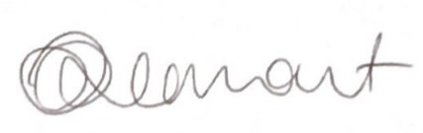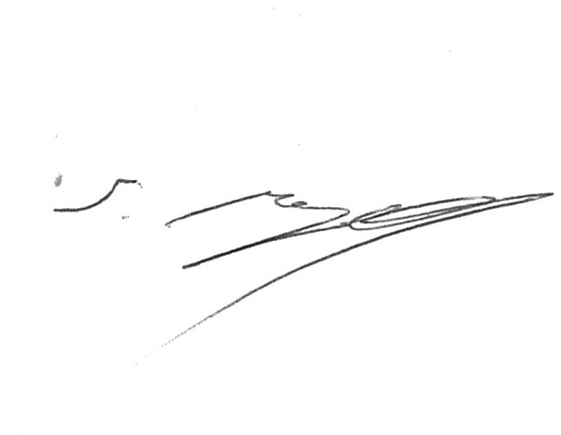
Tracie Smart Shaun Reynolds
Senior Planner Statutory Planning Services Team Leader

Date: 28 / 05 / 2021 Date: 1/6/2021

APPENDIX A

CONDITIONS

(1) The development shall be undertaken in accordance with the Statement of Environmental Effects and stamped approved plans detailed as follows except where modified by any of the following conditions:

Title/Plan: Site Plan
Drawing NR: G-1.0_000902
Revision: E
Dated: 17/5/2021

Title/Plan: Location Diagram
Drawing NR: G-2.0_000902
Revision: C
Dated: 17/05/2021

Title/Plan: DC Coupled Energy Storage Container Elevations
Drawing NR: G-3.0_000902
Revision: C
Dated: 23/3/2021

Title/Plan: Central Inverter, HV Switchboard, O/H Pole Elevations
Drawing NR: G-4.0_000902
Revision: C
Dated: 23/3/2021

Title/Plan: Security Fence Details
Drawing NR: G-5.0_000902
Revision: D
Dated: 23/3/2021
{Reason: To ensure that the development is undertaken in accordance with that assessed}

(2) A site rubbish enclosure shall be provided on the site for the period of the proposed construction works prior to commencement of any such work.
{Reason: Council requirement to prevent environmental damage by wind-blown litter}

(3) An erosion and sedimentation control plan is required to be submitted to Council for approval prior to the issue of a Construction Certificate. The approved Plan shall be implemented onsite prior to any site disturbance works being commenced and shall remain, in a maintained condition, until all site works are completed.
{Reason: Implementation of Council policy to reduce sediment pollution}

(4) A single stabilised vehicular access shall be provided to the construction site in accordance with the design described in Landcom’s “Managing Urban Stormwater Spills and Construction, 2002.
{Reason: Implementation of Council policy to reduce sediment pollution}

(5) Noise from the development (L_{Aeq}) shall not exceed the background (L_{A90}) by more than 5dB(A) at any time including any allowance for impulsiveness and tonal characteristics when measured at the most affected residence.
{Reason: Council requirement to prevent the generation of a noise nuisance}

(6) Construction work shall only be carried out within the following time:

Monday to Friday: 7 am to 6 pm
Saturday: 8 am to 1 pm
Sunday and public holidays: No construction work permitted
{Reason: Council requirement to reduce the likelihood of noise nuisance}

(7) All solid waste from construction and operation of the proposed development shall be assessed, classified and disposed of in accordance with the NSW Environment Protection Authority’s Waste Classification Guidelines. Whilst recycling and reuse are preferable to landfill disposal, all disposal options (including recycling and reuse) must be undertaken with lawful authority as required under the Protection of the Environment Operations Act, 1997.
{Reason: Council requirement to require compliance with the POEO Act, 1997}

(8) Should any contaminated, scheduled, hazardous or asbestos material be discovered before or during construction works, the applicant and contractor shall ensure the appropriate regulatory authority (eg Department of Planning, Industry and Environment (DPIE), WorkCover Authority, Council, Fire and Rescue NSW etc) is notified, and that such material is contained, encapsulated, sealed, handled or otherwise disposed of to the requirements of such Authority.

Note: Such materials cannot be disposed of to landfill unless the facility is specifically licensed by the Environment Protection Authority (EPA) to receive that type of waste.
{Reason: Council requirement to prevent the contamination of the environment}

(9) In the event of any Aboriginal archaeological material being discovered during earthmoving/construction works, all work in that area shall cease immediately and the Department of Planning, Industry and Environment notified of the discovery as soon as practicable. Work shall only recommence upon the authorisation of the DPIE.
{Reason: Council and statutory requirement to protect Aboriginal heritage}

(10) All noise mitigation measures proposed in the ‘Construction and Operational Noise Assessment Report, dated 17 March 2021’ submitted with this development application shall be adhered to at all times.
{Reason: Council requirement to prevent the generation of a noise nuisance}

(11) Prior to any Construction Certificate being issued by any Principal Certifying Authority, or the commencement of any construction works, a Construction Environmental Management Plan (CEMP) shall be submitted to and approved by Council.
{Reason: Legislative requirement under the Protection of the Environment Act, 1997, to prevent contamination of the environment}

(12) A well maintained spill kit must be available for use at all times in the bunded area inside which the transformer is kept to appropriately dispose of any unforeseen oil/chemical spills which may arise during the operation/maintenance phase of the development.
{Reason: Council requirement to ensure that no contamination of land or surface water occurs during the operational phase}

(13) The proposed access servicing the Solar Farm off Basalt Road shall be constructed by and at full cost to the Developer with construction of a Type BAL/BAR intersection to Council’s satisfaction.

The ingress/egress to the development (i.e. the BAL component) is to be constructed as a bitumen sealed culverted access (STD 1264) including sealing of minimum 30m access road passing the intersection of access road to Solar Farm and is to be of sufficient width so as to accommodate two-way traffic flow based upon the turning swept paths of ‘semi-trailer 19.0 m’ (utilising the Austroads design templates, with a turning speed of 5-15 km/hr) with such design width to ensure that at no stages will a semi-trailer be required to cross over onto the wrong side of Sheraton Road when either entering or exiting the proposed development.

All works required to fulfil the above condition are to be undertaken in accordance with Council's adopted AUS-SPEC #1 Development Specification Series - Design and Construction standards, with detailed engineering design plans being submitted to, and approved prior to any construction works commencing.

Should Council's Senior Development Engineer (or his representative) not undertake the required routine inspections during the course of construction of this condition, then a detailed list of inspections undertaken by an accredited private certifier verifying compliance with Council standards will be required to be lodged with Council prior to the issue of the Occupation Certificate for the proposed development.
{Reason: To provide a satisfactory means of entry/exit to the proposed development

(14) No vehicles larger than a “Semi-trailer” 19.0 m in length (utilising the Austroads design templates) are permitted to access the subject land and the development proposal.
{Reason: The internal manoeuvrability and access to the subject land and proposed development will only facilitate semi-trailer 19.0m in length or vehicles of lesser dimensions at this location}

(15) The proposed security access gateway(s), plus any associated security fencing, are to be ‘set-back’ at the proposed entry/exit driveway location, such that at a bare minimum an 19.0m Semi-Trailer is able to ‘stand clear’ and be totally contained within the subject lands allotment boundaries and not at any stage overhang onto the road reserve area.
{Reason: To provide safety for the travelling public utilising the public road system}

(16) Prior to any Construction works commencing, a separate ‘Road Opening Application’ (Section 138 Application under the Roads Act 1993) will be required to be made to Council’s Infrastructure Division, plus payment of appropriate fee/s to authorise works within the road reserve.
{Reason: Implementation of Council’s Policy and Section 138 of the Roads Act}

(17) Any alteration/damage to the footpath, kerbing and guttering, vehicular entrance/s, road or road shoulder including utility services, shall be repaired/restored at full cost to the developer and in accordance with Council's adopted AUS-SPEC #1 Development Specification Series - Construction Standards.
{Reason: Implementation of Council Policy}

(18) All vehicles must enter and exit the subject land and proposed development in a forward direction. No reversing of vehicles onto the public roadway system will be permitted.
{Reason: To provide safety for the travelling public utilising the public roadways}

(19) All loading and unloading of goods related to the development proposal shall be carried out within the confines of the allotment's boundary. Under no circumstances will the loading or unloading of goods on the public roadway system be permitted.
{Reason: Requirement of Council so as not to create adverse traffic conditions}

(20) No advertising, advertising sign/s or structure/s of any standard will be permitted to be displayed within (or overhang onto) the road reserve area/s.

Note: This area also includes the footpath reserve area.
{Reason: To protect the amenity of the travelling public utilising the surrounding roadways}

(21) A Dilapidation Report on Basalt Road and the intersection of Basalt Road and the Mitchell Highway (Wellington Road) is required prior to any construction works commencing. An additional Dilapidation Report is required following completion of the construction works, noting that any damage to Basalt Road and Wellington Road (Mitchell Highway) will require rectification at the applicant’s cost.
{Reason: Implementation of Council policy}

(22) A maintenance schedule is required to be submitted prior to any construction works for Basalt Road and Wellington Road (Mitchell Highway) for the construction period to allow for increased wear along the edges of the sealed pavement due to the increased passage of heavy vehicles.
{Reason: Implementation of Council policy}

(23) A detailed Traffic Management Report is to be submitted to Council prior to construction works commencing.
{Reason: To ensure appropriate traffic control measures are implemented for the proposed works}

(24) Prior to works commencing the Applicant shall ensure that a sign is erected on the work site in a prominent position at the front of the property showing:
- The name, address and telephone number of the Principal Certifier (PC) for the work;
- The name of the principal contractor for the building work and a telephone number on which that person may be contacted outside of working hours; and
- Stating that unauthorised entry to the work site is prohibited.

Such sign must be maintained on the site during the course of the building work and not be removed until the work has been completed.
{Reason: Statutory condition imposed by clause 98A of the EP&A Regulation 2000}

(25) The person having the benefit of this Development Consent must unless that person is the principal contractor, ensure that the principal contractor has been notified of the critical stage inspections and any other inspections that are specified by the appointed Principal Certifier (PC) to be carried out.

Note: The ‘principal contractor’ is the person responsible for the overall coordination and control of the carrying out of the building work.
{Reason: Statutory requirement imposed by the EP&A Act 1979}

(26) All excavations associated with the erection of the buildings and installation of associated services must be properly guarded and protected to prevent them from being dangerous to life or property.
{Reason: Council requirement for protection of public and tradesmen}
(27) All building work must be carried out in accordance with the provisions of the Building Code of Australia.
{Reason: Prescribed statutory condition under EP&A Act}

(28) A site rubbish container shall be provided on the site for the period of the construction works prior to commencement of any such work.
{Reason: Council requirement to prevent pollution of the environment by wind-blown litter}

(29) An Asset Protection Zone (APZ) of minimum width of 10 m shall be provided around the outside perimeter of the PV modules and associated building infrastructure. The APZ shall be provided and maintained in accordance with the requirements of the “Planning for Bush Fire Protection 2019” guidelines for the life of the subject development.

Such APZ may be implemented as ‘managed land’ where by the required minimum width of 10 m is provided as one or a combination of the following:

- The existing grassland vegetation is maintained in a low fuel condition by regularly mowing to achieve a nominal height no greater than 100 mm; and/or
- Gravel paved access roadway.

The APZ applicable to each structure shall be established prior to the issue of that building’s Occupation Certificate(s).
{Reason: Council requirement in consideration of the Planning for Bush Fire Protection 2019 guidelines to assist in the protection of the development’s infrastructure from grassland fires}

(30) Any water storage tank provided to the development for fire-fighting purposes shall have a minimum effective storage of 10,000 litres of water (i.e. storage capacity above its outlet). Any on-site static water storage tank shall meet the following requirements:

    - For an under-ground storage tank:
      - Unobstructed access provided directly to the storage for fire-fighting appliances;
      - A hardened surface for truck access is provided within 4 m of the access hole;
      - An access hole of at least 200 mm provided in the lid of the storage tank;
    - For an above-ground storage tank:
- A 65 mm Storz outlet with a metal gate or ball valve and blanking cap provided at the lowest possible point;
Example of a Storz Outlet with a Gate Valve & a Ball Valve
- The tank is to be of concrete or metal construction (plastic or fibreglass is not acceptable); and
- The tank and its Storz outlet must be located so that it is accessible by fire-fighting units and personnel.
{Reason: Council requirement & implementation of ‘Planning for Bush Fire Protection 2019’ guidelines for adequate water supply for fire-fighting}

(31) The development is to be operated in accordance with the Bush Fire Assessment and Emergency Management and Operations Plan, Report Reference 210066, dated 24.03.21.
{Reason: To ensure the development complies with Section 8.3.5 of the Planning for Bush Fire Protection 2019}

(32) Prior to the issue of an Occupation Certificate, the landscaping and associated infrastructure as detailed in approved plan, ‘Landscape Screening Plan, Drawing #02, Revision A, dated 18 March 2021’ & ‘Landscape Specification Notes, Drawing #04, Revision -, dated 18 March 2021’ shall be established and maintained to at least the standard specified on the approved development plans. Such landscaping shall be maintained for the life of the development in accordance with such plans and the document written by Jenna Amos of MJM Consulting Engineers, dated 19 May 2021.
{Reason: To maintain and improve the aesthetic quality of the development}

(33) The solar farm, associated infrastructure, access and driveway are to be constructed and sited in a manner consistent with the recommendations detailed in the submitted document titled, ‘Dubbo Solar Farm Flood, Drainage and Groundwater Assessment, dated 15 March 2021.’
{Reason: To ensure the development is sited in a manner that will not be impacted by the 1% AEP event}

(34) A decommissioning plan is to be submitted Council for review and approval no later than 12 months prior to the proposed cessation of the operation.
{Reason: To ensure the land will be rehabilitated to a suitable state for agricultural production}

(35) The solar farm is to be operated in accordance with the document written by Jenna Amos of MJM Consulting Engineers, dated 19 May 2021 and the document titled ‘Gas Fire Extinguishing System’ in relation to managing the battery storage fire risk.
{Reason: To ensure the risk of fire originating from the battery storage containers is minimised.

(36) The solar farm shall be constructed and operated in accordance with the Impact and Avoidance Minimisation Measures detailed in Chapter 4, page 28 of the document titled ‘Biodiversity Assessment, Report No: 221249/BAR, Rev: 001B, dated 15 March 2021.’
{Reason: To ensure the solar farm is constructed and operated in a manner that avoids and minimises impacts on biodiversity}

NOTES

(1) A separate application is required to be submitted to either Council or a registered certifier to obtain a Construction Certificate to permit the erection of the proposed structures.

(2) The proposed structures shall not be occupied or used until the appointed Principal Certifier (PC) has first issued an Occupation Certificate.

(3) If Council is engaged to act as the Principal Certifier for the Construction Certificate application(s) the following shall be included with such application(s):

- All structural details including specifications and design drawings and statement(s)/certificate(s) by the design engineer stipulating the Australian Standards that the module tracking systems, inverter, switchboard and battery container structures and associated footing design comply with, including its design wind load parameters.

(4) Offensive noise as defined under the Protection of the Environment Operations Act, 1997 shall not be emitted from the proposed development.

Air impurities as defined under the Protection of the Environment Operations Act, 1997 shall not be released or emitted into the atmosphere in a manner which is prejudicial to the health and safety of occupants, the surrounding inhabitants or the environment.

(5) The development shall be carried out in accordance with Essential Energy’s correspondence dated 29 April 2021 (copy attached).

(6) Your attention is drawn to Council’s ‘Planning Agreement Policy for Solar and Wind Energy Farms’ dated 28 April 2021 and its applicability to this development. Please contact Council’s Manager Growth Planning to discuss further.

